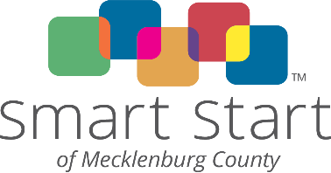 Mecklenburg County Partnership for Children FY 2023-24 Logic Model
Activity: Activity Provider:
EC Profile ID: PSC:
PIDs:
Need Statement  Why? | Target Population  Who? | Program or Activity Elements  What? | Outputs  How Many? | Outcomes  So What?  By June 30, 202X, … | How does outcome impact EC Profile or other long-term goal?
 |  | (One activity or component per line/row!)
Staffing and Training Requirements:
Job Title | FTE | Minimum Education & Experience Requirements

Other Requirements:

Community Collaborations:

